**Online Farming Route System**

**Abstract:**

### The Online Farming Route System is designed to optimize the agricultural logistics and routing system, providing farmers and transporters with efficient routes for delivering farm produce to markets and processing centers. This system addresses critical issues in agricultural supply chains, such as inefficient route management, time delays, and increased costs due to poorly planned logistics. By incorporating advanced algorithms for route optimization and real-time data analytics, the system ensures that farm products reach their destinations in a timely and cost-effective manner. The system leverages geographic information system (GIS) technology to calculate optimal routes, taking into account factors such as road conditions, weather, traffic, and delivery time windows. The proposed system aims to support small-scale farmers and improve their market access, ensuring higher profitability and minimizing losses. The ****Online Farming Route System**** is a web-based application designed to empower farmers by providing personalized agricultural advice and management solutions. The system offers each farmer a unique profile, enabling tailored recommendations for crop care, disease diagnosis, and other vital farming operations. By integrating advanced algorithms and a user-friendly interface, the application helps farmers optimize crop management, improve productivity, and diagnose crop diseases with accuracy. Additionally, farmers can access customized solutions based on real-time data and expert inputs, making the app a valuable tool for enhancing decision-making processes in modern agriculture. The ultimate goal of the project is to improve agricultural efficiency, reduce crop losses due to diseases, and ensure farmers receive relevant, actionable advice to improve their yields and sustainability.

### Keywords: Route system, farming, crop, web based.

**CHAPTER 1**

**INTRODUCTION**

**1.1 Aim of the Study:**

The aim of this study is to develop an efficient and user-friendly Online Farming Route System that will optimize route planning for farmers and transporters, thereby reducing delivery time, minimizing costs, and improving the overall agricultural supply chain.

**1.2 Objectives:**

1. To design a system that provides optimal routes for the transportation of agricultural goods from farms to markets and processing centers.
2. To incorporate real-time data, including weather, traffic, and road conditions, into the route optimization process.
3. To enhance the accessibility of farmers to markets through improved logistics, thereby increasing their profitability.
4. To reduce post-harvest losses by minimizing transportation delays through efficient route planning.
5. To develop a user-friendly interface that allows farmers and transporters to easily plan and modify routes.

**1.3 Scope of Study:**

The scope of this study includes the design, development, and implementation of an online system for optimizing farming routes. The system is intended to support small-scale and large-scale farmers, as well as transporters, by providing real-time, data-driven route recommendations. It focuses on improving the efficiency of agricultural logistics, taking into consideration factors such as distance, road conditions, weather, and traffic patterns. The system will also incorporate the needs of different types of crops, ensuring that perishable goods are prioritized for faster delivery.

The study will cover the following areas:

* Route optimization algorithms and their application in agriculture.
* The use of GIS technology and real-time data for accurate route planning.
* The integration of the system with existing farming and supply chain platforms.
* User interface design for ease of use by farmers and transporters.

**1.4 Motivation:**

The agricultural sector plays a crucial role in the economy of many countries, yet inefficiencies in logistics and transportation can lead to significant post-harvest losses and reduced income for farmers. In many cases, poor road conditions, unpredictable weather, and traffic delays exacerbate these issues, making it difficult for farmers to deliver their products on time. Small-scale farmers, in particular, face challenges in accessing markets due to limited resources and logistical support.

This project is motivated by the need to support farmers in optimizing their logistics operations, reducing costs, and improving profitability. By providing a system that allows farmers to plan efficient routes, the Online Farming Route System aims to ensure that farm produce reaches markets in the best possible condition. The motivation also stems from the growing importance of sustainable farming practices, where minimizing transportation costs and fuel consumption can contribute to environmental conservation.

**1.5 Problem Statement:**

Agricultural supply chains are often plagued by inefficiencies in transportation logistics, leading to increased delivery times, higher costs, and significant post-harvest losses. Farmers, especially those in rural areas, lack access to efficient route planning systems that can help them transport their goods to markets in a timely and cost-effective manner. Current systems either do not account for real-time data such as weather and traffic, or they are too complex for small-scale farmers to use effectively. These inefficiencies not only reduce profitability for farmers but also contribute to food waste, making it necessary to develop a comprehensive solution.

The problem addressed in this study is the need for an optimized and user-friendly system that can assist farmers and transporters in planning the best possible routes for delivering agricultural products, taking into account factors like distance, road conditions, and real-time data. The Online Farming Route System aims to solve these issues by providing a reliable, data-driven solution that improves the overall efficiency of agricultural logistics.

**1.6 Introduction:**

Agriculture remains the backbone of many economies worldwide, providing food security, employment, and raw materials for various industries. However, inefficiencies in the agricultural supply chain, particularly in logistics and transportation, can lead to significant challenges for farmers and transporters. These challenges are especially pronounced in developing regions, where inadequate infrastructure, poor road conditions, and unpredictable weather patterns contribute to delays in delivering farm products to markets.

In many cases, small-scale farmers struggle to access urban markets, leading to reduced profitability and post-harvest losses. The transport of agricultural produce is often done without any systematic route planning, resulting in inefficient use of time and resources. Moreover, perishable goods such as fruits and vegetables are highly vulnerable to delays, leading to spoilage and economic losses.

To address these challenges, the Online Farming Route System aims to provide an innovative solution that optimizes route planning for farmers and transporters. By leveraging modern technologies such as GIS, machine learning, and real-time data analytics, this system will provide the most efficient routes based on current road conditions, traffic, and weather forecasts. The system will not only optimize the route but also prioritize perishable goods, ensuring that they reach the market before spoilage occurs.

Route optimization in logistics has been extensively studied in other industries, such as e-commerce and freight transportation, but its application in agriculture remains limited. This project seeks to fill that gap by developing a system specifically designed for the agricultural sector. By providing farmers with easy-to-use tools for planning and modifying routes, the system will empower them to make informed decisions that enhance the efficiency of their operations.

The introduction of this system is timely, as the global demand for food continues to rise, and the need for efficient, sustainable agricultural practices becomes increasingly critical. According to the Food and Agriculture Organization (FAO), around 30% of global food production is lost due to inefficiencies in the supply chain, much of which occurs during transportation. By improving the logistics of agricultural transport, the Online Farming Route System has the potential to reduce food waste, improve farmers' income, and contribute to the overall sustainability of the agricultural sector.

This study will focus on the development and implementation of the system, using both algorithmic route optimization techniques and real-time data analytics. The system will be designed to accommodate the unique needs of different types of farms and products, ensuring that even small-scale farmers can benefit from its features. The ultimate goal is to create a scalable and sustainable solution that can be implemented in various agricultural regions, improving market access and reducing logistical inefficiencies.

In summary, the Online Farming Route System represents a novel approach to tackling the logistical challenges faced by farmers in delivering their products to markets. By combining modern technology with the specific needs of agriculture, the system aims to improve the overall efficiency of the agricultural supply chain, reduce post-harvest losses, and enhance the profitability of farmers. This project will significantly contribute to the growing body of research on sustainable agricultural practices and provide a practical tool for farmers worldwide.

The main idea of this project is to develop a comprehensive web application specifically designed to support farmers in managing various aspects of agriculture efficiently. The application will serve as a digital tool that offers personalized advice and tailored solutions to help farmers optimize their farming operations. One of the standout features of the system is that it provides each farmer with a unique profile, allowing the application to offer individualized recommendations and advice based on their specific farming needs, crop types, and local conditions.

Farmers can use this application to manage crucial agricultural activities, such as crop care and disease diagnosis. The app offers a user-friendly interface where farmers can input information about their crops, soil conditions, and any visible crop diseases. Based on the data provided, the system uses machine learning algorithms to diagnose the health of crops and recommend appropriate treatments. For example, if a farmer reports symptoms of a crop disease, the app can diagnose the issue and suggest specific remedies or preventative measures, customized to the farm's environmental conditions.

The web application is not just limited to crop care and disease diagnosis; it also serves as a broader agricultural management tool. It provides real-time updates and recommendations on various factors that impact farming, including weather forecasts, soil health, irrigation needs, and pest control. By incorporating these features, the application empowers farmers to make informed decisions, ultimately improving productivity and reducing losses.

In conclusion, this web application acts as a one-stop platform that helps farmers manage all aspects of their farming operations while providing personalized support. The goal is to enhance agricultural efficiency, reduce disease impact, and offer data-driven solutions that contribute to improved yields and sustainable farming practices.

The **Online Farming Route System** is an innovative web-based application developed to assist farmers in effectively managing their agricultural practices. This system offers personalized solutions through user-friendly features and automated processes, specifically designed to improve the overall farming experience. The main objective of the project is to provide a platform that allows farmers to receive customized advice, monitor crop health, diagnose diseases, and optimize farm management.

In this project, there are **three distinct user roles**: **Admin**, **Expert**, and **Farmer/User**. Each role is designed to perform specific functions that contribute to the effective operation of the system. The key functions for each user role are outlined as follows:

1. **Admin:**
   * The **admin** is responsible for managing user accounts. After logging in with a pre-defined username and password (admin/admin), the admin can view all pending accounts and activate user and expert accounts. Only after the activation of accounts, can users and experts access the system.
2. **Expert:**
   * The **expert** plays a crucial role in providing farming advice. After signing up, experts wait for the admin's approval to access the system. Once activated, experts can log in and view requests submitted by farmers. These requests often consist of crop images and disease symptoms. Based on this information, experts offer tailored advice and suggestions.
3. **User/Farmer:**
   * The **farmer** or **user** role is the core of the system, as it allows the end-user (farmer) to utilize the features for managing crop care. After signing up, the farmer’s account must be activated by the admin before access to the system is granted. Once logged in, farmers can update their profile, upload images of crops, describe symptoms of issues they observe, and request advice from experts. Farmers can also track the status of their requests and view advice once provided.

**System Setup and Configuration**

To successfully run the system, several installation steps are required:

1. **Database Setup:**
   * Install **MySQL** and create the necessary database by copying the content from the DB.txt file into the MySQL console. This will initialize the database that stores all the user data, crop information, expert advice, and more.
2. **Python Setup:**
   * Install **Python 3.7.2**, which is necessary to run the back-end scripts for the application. After installation, open the command prompt, copy the content from the requirements.txt file, and run the installation to ensure all dependencies are correctly installed.

The integration of user roles and the technology stack enables efficient agricultural management, from diagnosing crop diseases to receiving expert advice. By providing different roles and permissions, this system ensures seamless communication and assistance for farmers, promoting more informed decision-making and optimized farming practices.

Through this system, farmers not only receive personalized advice but also contribute to a community of agricultural experts and other farmers, thus improving their crop yields and overall productivity.

Top of Form

Bottom of Form

**CHAPTER 2**

**LITERATURE SURVEY**

1. **Wolfert, S., Ge, L., Verdouw, C., & Bogaardt, M.-J. (2017).**  
   This paper reviews the role of big data in smart farming and its potential impact on decision-making processes. It highlights how data-driven approaches can improve efficiency and sustainability in agriculture, focusing on the challenges of data integration, interoperability, and security in modern agricultural systems.
2. **Zhang, N., Wang, M., & Wang, N. (2002).**  
   This article provides a global overview of precision agriculture, emphasizing the integration of information technology, control systems, and data collection tools. The review outlines key technologies such as GPS, GIS, and sensors, and discusses their application in enhancing agricultural productivity and sustainability.
3. **Food and Agriculture Organization of the United Nations (FAO) (2019).**  
   The briefing paper discusses the application of digital technologies in agriculture and rural development. It highlights key technologies such as blockchain, IoT, and AI, providing insights into how these tools can promote sustainable agriculture, increase food security, and enhance rural livelihoods.
4. **Verdouw, C., Beulens, A., Wolfert, S., & Rialland, A. (2016).**  
   This paper explores the virtualization of food supply chains through the Internet of Things (IoT). The study demonstrates how IoT can enable real-time visibility and control over agricultural processes, improving supply chain transparency and responsiveness to market demands.
5. **Jha, K., Doshi, A., Patel, P., & Shah, M. (2019).**  
   This comprehensive review discusses the integration of artificial intelligence (AI) in agricultural automation. The paper analyzes various AI applications, including crop monitoring, disease detection, and autonomous machinery, offering insights into how AI can enhance decision-making and productivity in modern farming.
6. **Khanal, S., Karkee, M., & Steward, B. L. (2017).**  
   This paper reviews emerging automation technologies in crop production, such as robotics, drones, and sensors. It evaluates the potential of these technologies to optimize crop management and improve productivity, while also considering the technical challenges of their adoption in agriculture.
7. **Liakos, K. G., Busato, P., Moshou, D., Pearson, S., & Bochtis, D. (2018).**  
   This review paper presents the role of machine learning (ML) in agriculture, discussing various algorithms used for data analysis in precision farming. The paper covers applications such as yield prediction, crop disease detection, and weed identification, showcasing the benefits of ML in enhancing agricultural practices.
8. **Aggarwal, C. C. (2015).**  
   In this textbook chapter, the author discusses the role of data mining in precision agriculture. The chapter covers various data mining techniques, such as clustering and classification, and their application in crop management, soil analysis, and pest control, highlighting the potential of data-driven agriculture.
9. **Walter, A., Finger, R., Huber, R., & Buchmann, N. (2017).**  
   This article discusses the importance of smart farming technologies in developing sustainable agricultural systems. The authors emphasize the use of sensors, big data, and IoT to monitor and manage farming operations, ultimately improving efficiency and reducing environmental impact.
10. **Ghosh, B., & Maheshwari, S. (2020).**  
    This paper reviews the use of IoT in smart agriculture, focusing on its applications in soil monitoring, crop health assessment, and irrigation management. The authors analyze various IoT frameworks and provide insights into how these technologies can help farmers make data-driven decisions.
11. **Sundmaeker, H., Verdouw, C., Wolfert, S., & Perez Freire, L. (2016).**  
    This book chapter introduces the "Internet of Food and Farm 2020" project, which aims to digitize the agricultural sector using IoT technologies. The authors discuss how IoT can improve supply chain management, reduce food waste, and enhance sustainability in the agricultural sector.
12. **Patil, S. K., & Kale, N. V. (2016).**  
    This paper presents a model for smart agriculture using IoT, highlighting how real-time data collection and analysis can improve crop management. The proposed system includes sensors for monitoring soil moisture, temperature, and humidity, enabling farmers to optimize irrigation and fertilization practices.
13. **Kim, Y., Evans, R. G., & Iversen, W. M. (2008).**  
    This study discusses the use of a distributed wireless sensor network for remotely sensing and controlling irrigation systems. The paper demonstrates how real-time data from soil and weather sensors can be used to automate irrigation, leading to water conservation and improved crop yields.
14. **Mohanraj, I., Ashokumar, K., & Naren J. (2016).**  
    This paper explores the use of IoT for field monitoring and automation in agriculture. The authors propose a system that integrates sensors and actuators to monitor environmental parameters and automate farming tasks, improving efficiency and reducing labor costs in agricultural practices.
15. **Kamilaris, A., Kartakoullis, A., & Prenafeta-Boldú, F. X. (2017).**  
    This review examines the role of big data in agriculture, focusing on its applications in precision farming. The authors analyze how big data technologies can be used to predict crop yields, optimize resource use, and monitor environmental conditions, providing a roadmap for future research in this area.

**CHAPTER 3**

**EXISTING METHOD**

* + - Traditionally, agricultural practices are manually handled by farmers, relying on their experience and traditional knowledge.
    - Information on best farming practices and pest management is not readily available, resulting in lower yields and increased crop losses.
    - Identifying crop diseases manually can be time-consuming, leading to delays in treatment and increased crop damage.
    - Misdiagnosis of crop diseases is common due to the reliance on visual inspection and traditional knowledge, which can lead to infective treatment.

**CHAPTER 4**

**PROPOSED METHOD**

The **Online Farming Route System** is a comprehensive web and mobile application designed to cater to the unique needs of farmers by providing them with real-time, personalized support. Its accessibility is a key feature, as it can be used from any location, allowing farmers to manage their crops and farming operations efficiently. The application offers a flexible platform for farmers, experts, and other agricultural stakeholders to interact and exchange knowledge. Through a user-friendly interface, the system ensures that all users, regardless of technical expertise, can easily navigate and use the application.

One of the core features of the platform is the ability for farmers to upload images of their crops or describe symptoms they observe. This input is analyzed either through an AI-driven process or through expert review, depending on the system design. The application provides a diagnosis based on the information provided and offers potential treatment options or solutions. This diagnostic capability allows farmers to quickly identify issues affecting their crops, such as pest infestations, diseases, or nutrient deficiencies. As a result, farmers can take timely action to prevent further damage and boost productivity, minimizing the negative impact on their crops.

Furthermore, the system is designed to assist farmers throughout various stages of the farming process. From crop planning and sowing to pest management and harvest optimization, the application offers tailored advice and support. The use of real-time data and expert input helps farmers make informed decisions, leading to more efficient resource use and higher crop yields. Additionally, the application integrates a community feature where farmers can share their experiences, success stories, and challenges, thereby creating a knowledge-sharing network that enhances collective learning.

Overall, this proposed method ensures a holistic approach to modern farming by combining technological advancements with practical farming expertise. The platform not only empowers farmers with the necessary tools to manage their crops but also fosters a collaborative environment for agricultural innovation. This comprehensive solution serves as a valuable tool in addressing the evolving challenges of agriculture, ensuring sustainability, and enhancing farm productivity across different farming operations.

* This is web and mobile application which is very flexible to use and can be accessed from anywhere.
* A platform where farmers can interact with peers and agricultural experts to resolve queries, enhancing the exchange of knowledge.
* Farmers can upload images or describe symptoms of their crops, and the app will provide potential diagnosis and treatment options. This feature helps farmers quickly identify and address issues affecting their crops.
* The application can be used in various farming operations, from crop planning to pest management, ensuring comprehensive support throughout the farming process.

**CHAPTER 5**

**FUNCTIONAL AND NON REQUIREMENT:**

* User can login by providing user name and password.
* Admin can view farmer accounts.
* Admin can activate or deactivate farmer accounts.
* Admin can manage the platform.
* Farmers can seek advice from experts.
* Experts can offer guidance and solutions.
* Users can view and update their personal information.
* Users can cultivate crops based on crop plan.
* User can scan or upload image of effected part of plant to identify diseases and pests.

**NON FUNCTIONAL REQUIREMENTS**

* Performance
* Reliability
* Accessibility
* Security
* Compatibility

**CHAPTER 6**

**MODULES**

The System of after careful analysis has been identified to be presented with the following modules.

1. User Management.

2. Crop Planning.

3. Disease Diagnosis.

4. Expert Advice.

**1. User Management**

* Users can register and login using email or phone number.
* Users can view and update their profiles.
* Farmers consults an agriculture experts and logout.
* User can scan or upload image of effected part of plant to identify diseases and pests.

**2. Crop Planning**

* Provides step-by-step instructions for farming various crops.
* Offers a schedule for planning, growing, and harvesting based on crop type and local conditions.
* Farmers enter the new crop status. The crop manager updates the crop status.

**3. Disease Diagnosis**

* Users can upload or scan images of affected plants for disease identification.
* Database of diseases and treatments maintain a database that maps identified diseases to recommended treatments.
* Suggests appropriate fertilizers and treatments based on the diagnosed disease.

**4. Expert Advice**

* Enables users to chat with agriculture experts.
* Provides a repository of frequently asked questions and solutions.
* The expert manager finds available experts. If an expert is available, a consultation is schedule and a success message is displayed.

**CHAPTER 7**

**TECHNICAL ARCHITECTURE**

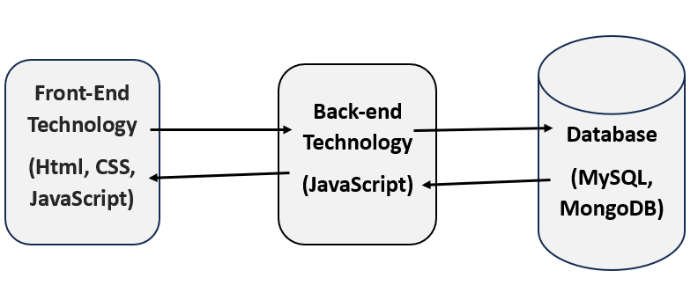

The diagram you’ve shared illustrates a **three-tier technical architecture** used in web development, which typically consists of:

1. **Front-End Technology:**
   * This represents the **client-side** or **presentation layer** that users interact with directly.
   * It includes technologies like:
     + **HTML (HyperText Markup Language):** Responsible for structuring the content of web pages.
     + **CSS (Cascading Style Sheets):** Used to style and design the HTML elements to enhance visual appeal and user experience.
     + **JavaScript:** Adds interactivity to web pages, handling client-side logic and making web pages dynamic.
2. **Back-End Technology:**
   * This is the **server-side** or **business logic layer** that handles requests from the front end and processes the data.
   * **JavaScript** is used on the back end, most commonly through frameworks such as **Node.js**, which allows server-side scripting.
   * This layer manages the communication between the front-end and the database, executing business rules and fetching or updating data.
3. **Database Layer:**
   * This tier is responsible for storing, retrieving, and managing data.
   * The diagram indicates two types of databases:
     + **MySQL:** A **relational database** that organizes data in tables and uses SQL (Structured Query Language) for querying.
     + **MongoDB:** A **NoSQL database** that stores data in flexible, JSON-like documents, allowing for more dynamic and scalable data structures.

**SYSTEM ARCHITECTURE**

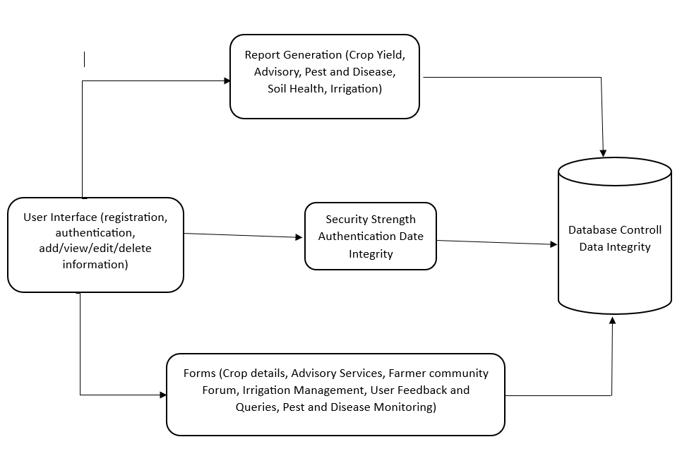

The diagram illustrates the **system architecture** for an **Online Farming Route System** designed to support farmers by providing various services related to crop management, advisory services, pest and disease monitoring, and irrigation management. Here's a breakdown of each component:

**1. User Interface (UI):**

* This is the **front-end** layer where users (farmers) interact with the system.
* **Functionalities include:**
  + **Registration and Authentication:** Farmers can create accounts, log in, and access their personalized profiles.
  + **Add/View/Edit/Delete Information:** Farmers can manage their data regarding crops, soil health, irrigation, etc.

**2. Forms:**

* A key feature within the UI, forms allows users to input and manage various agricultural aspects.
* **Includes:**
  + **Crop Details:** Farmers can add, view, or update crop information.
  + **Advisory Services:** The system provides personalized recommendations based on input.
  + **Farmer Community Forum:** A space where farmers can discuss issues and share solutions.
  + **Irrigation Management, Pest and Disease Monitoring:** Input and monitor irrigation schedules, and use the system to diagnose crop diseases and pests.

**3. Security Layer:**

* Ensures the protection and privacy of user data through **Authentication** and **Data Integrity** measures.
* **Authentication** ensures that only authorized users access the system.
* **Data Integrity** ensures that the data stored is accurate, consistent, and not tampered with.

**4. Database Control & Data Integrity:**

* The **back-end database** that stores all data related to users, crops, advisory services, pest and disease monitoring, and irrigation management.
* **Database Control**: Manages the storage, retrieval, and manipulation of data.
* **Data Integrity**: Ensures that all data in the system remains accurate and unaltered.

**5. Report Generation:**

* The system generates reports based on user input, including:
  + **Crop Yield:** Provides farmers with an estimate of their crop yield.
  + **Advisory Services:** Generates reports on pest and disease management, soil health, and irrigation.
* These reports are crucial for decision-making and improving farm productivity.
* Farmers interact with the system through the **User Interface** to input, manage, and access information.
* Data is securely transmitted to the **Database** after going through security checks for authentication and data integrity.
* Farmers access features like advisory services, irrigation management, and disease diagnosis through **Forms**.
* Based on the data, the system generates personalized **Reports** for farmers, helping them manage their crops efficiently.

**CHAPTER 8**

**SOFTWARE AND HARDWARE REUIREMENT**

**Software Requirements :**

Operating System :  Windows 10

Platform : Node.js

Technologies : Html, CSS, Java Script

IDE : Visual Studio Code (VS Code)

Database : MySQL, MongoDB

**Hardware Requirements:**

Processor    : I3.

 Ram            : 8GB.

 Hard Disk   : 1TB

**CHAPTER 8**

**UML DAIGRAMS**

**Use case diagram:**

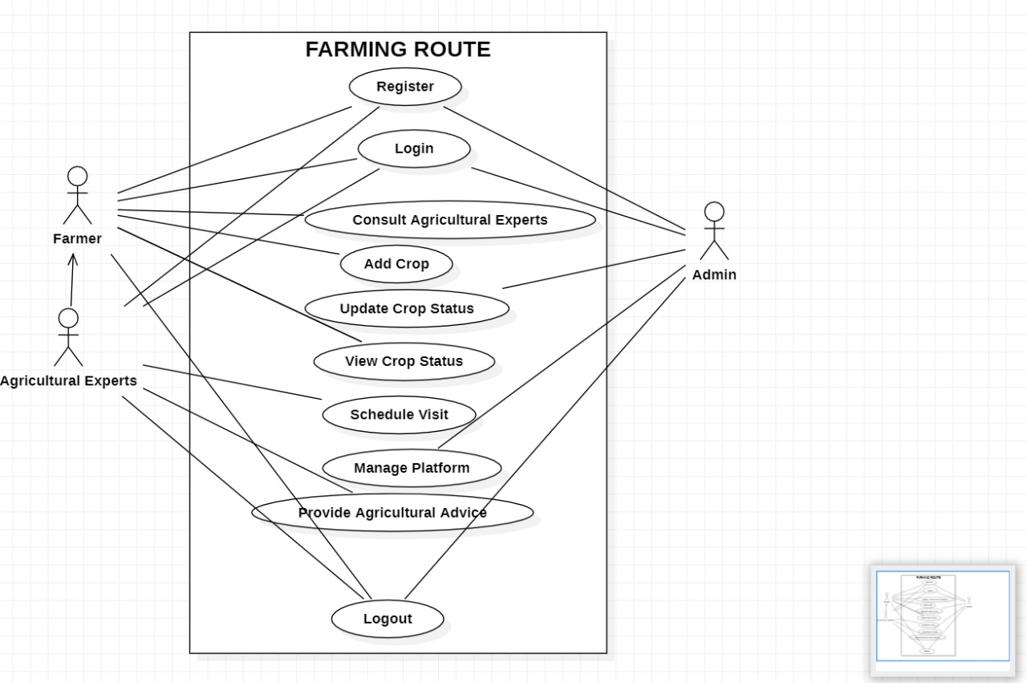

**Class diagram:**

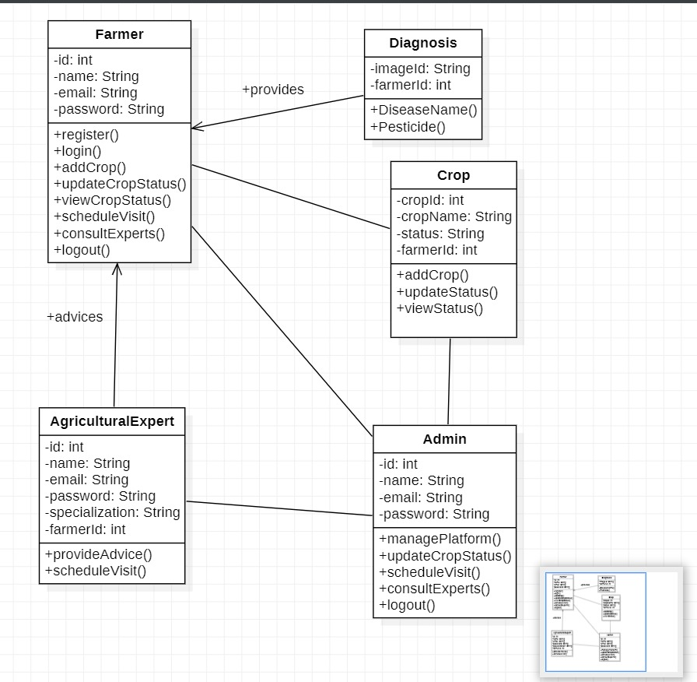

**Sequence diagram:**

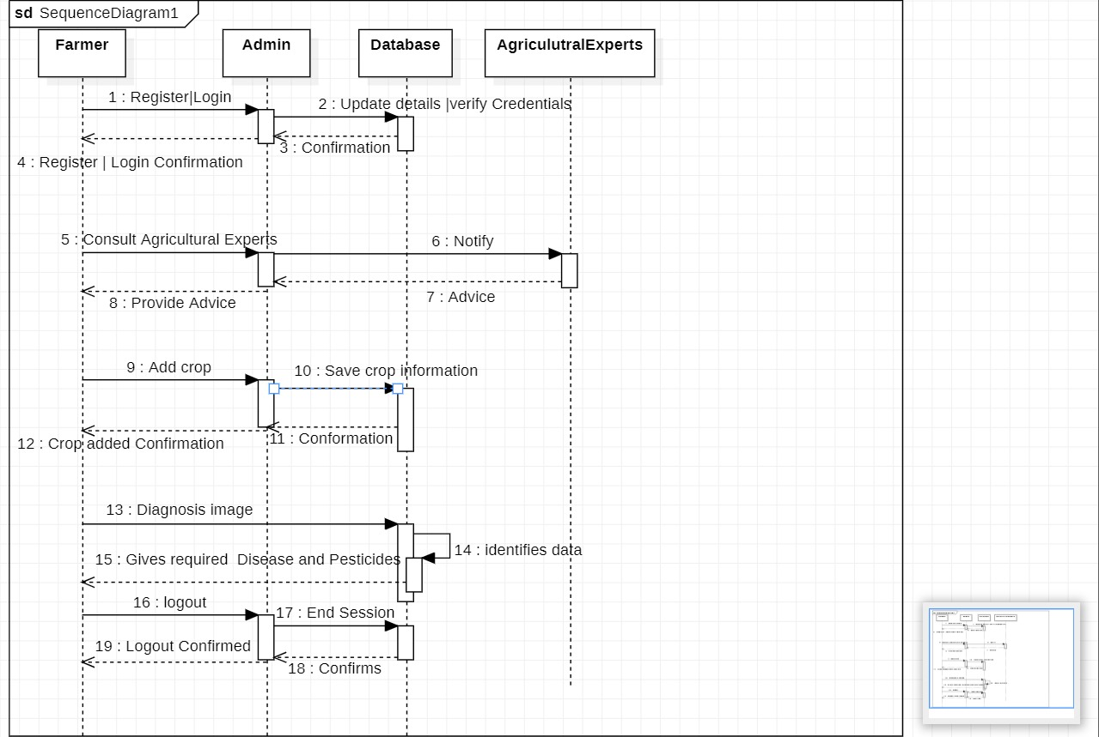

**Activity diagram:**

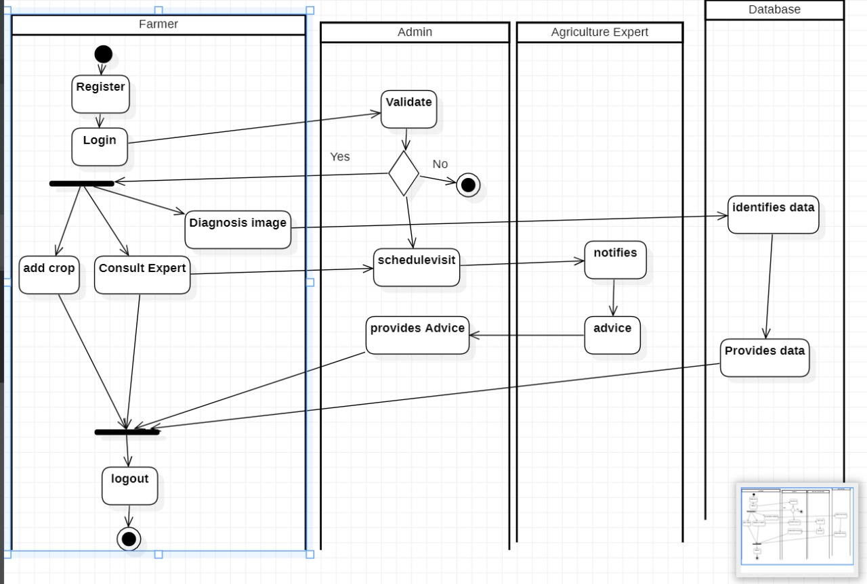

**CHAPTER 9**

**RESULT**

In this project we have created 3 different users and each user can perform its assigned activities. Below describing functions of each users

1. Admin: admin can login to system using username and password as ‘admin and admin’. After login admin can view all accounts and can activate pending users accounts. Once activated then only users can login to system
2. Experts: experts can sign up with the application and wait for admin to activate his account. After account activation expert can login to system and then can view ‘Advice Request’ from all farmers and provide suggestions
3. User/Farmer: user can sign up and login to system after account activation. After login user can update current profile, can upload crop image and then enter symptoms and send request to experts. User can view all pending or provided suggestions from experts.

To run project install MYSQL database and then open MYSQL console and then copy content from ‘DB.txt’ file and paste in MYSQL console to create database. Install python 3.7.2 and then copy content from ‘requirements.txt’ and then open command prompt and paste all contents and press enter key to install all packages.

SCREEN SHOTS

Double click on ‘run.bat’ file to start python web server and then will get below page

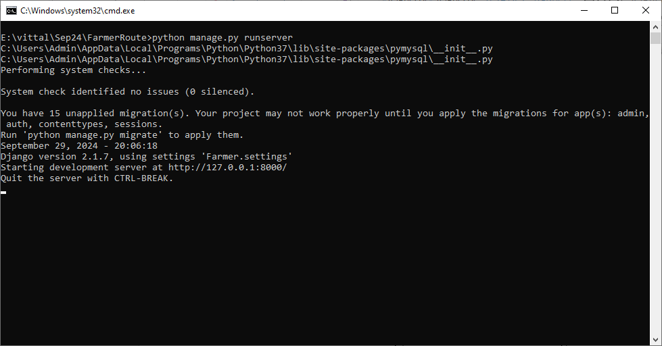

In above screen python server started and now open browser and enter URL as <http://127.0.0.1:8000/index.html> and press enter key to get below page

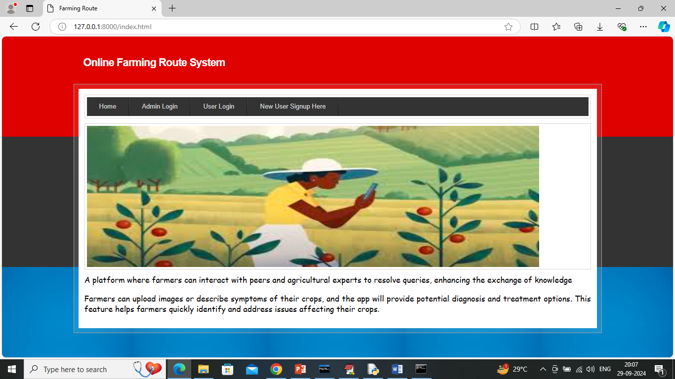

In above screen click on ‘New User Sign up’ link to get below page

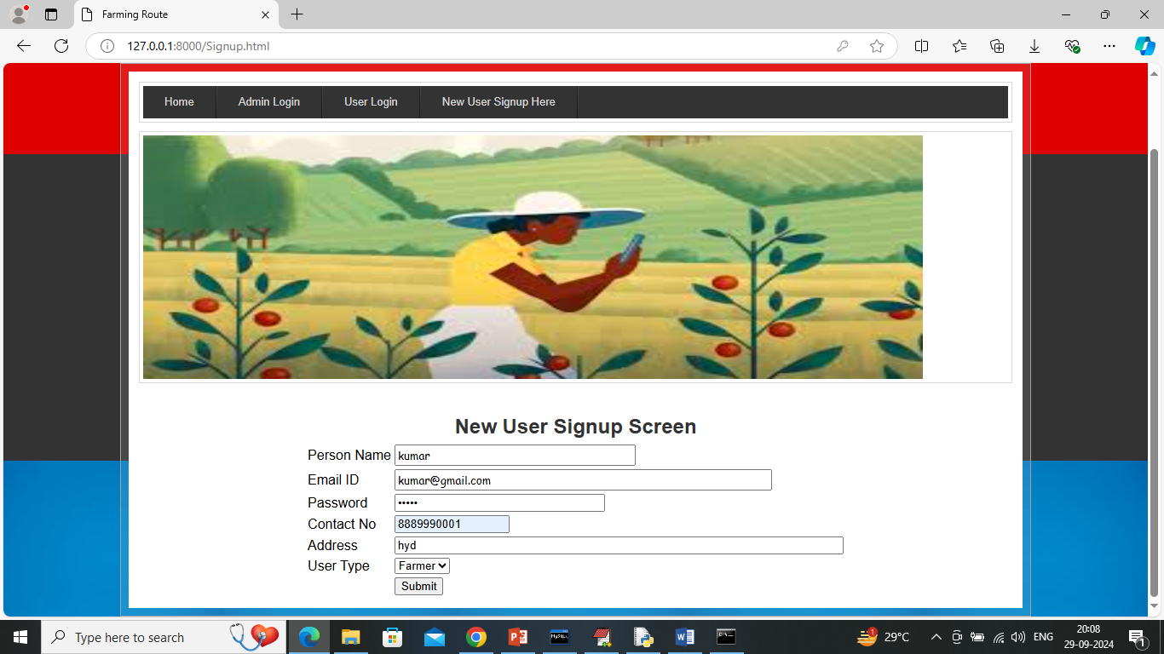

In above screen farmer user is entering sign up details and then press button to get below page

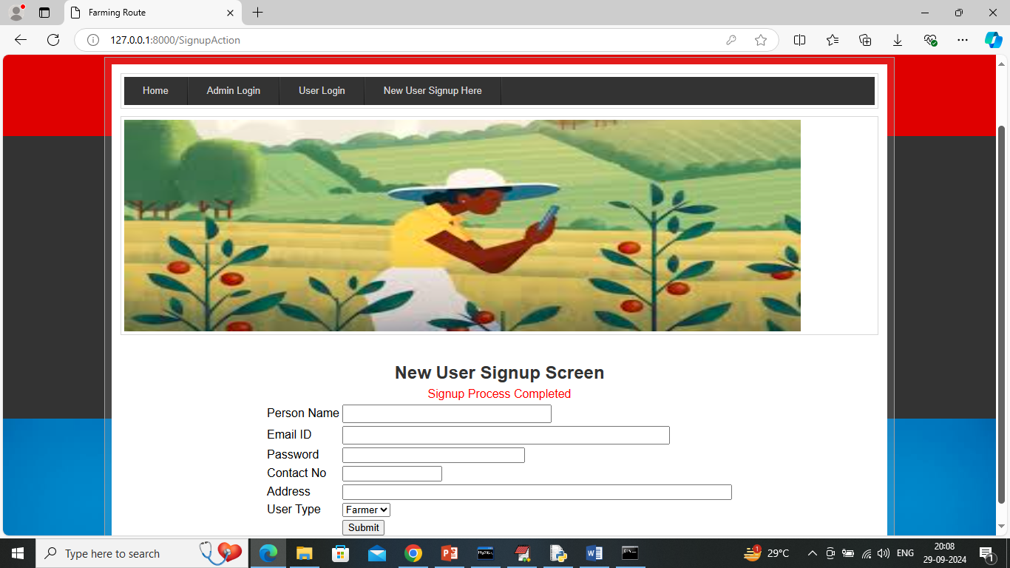

In above screen Farmer sign up task completed and similarly sign up ‘Expert user’

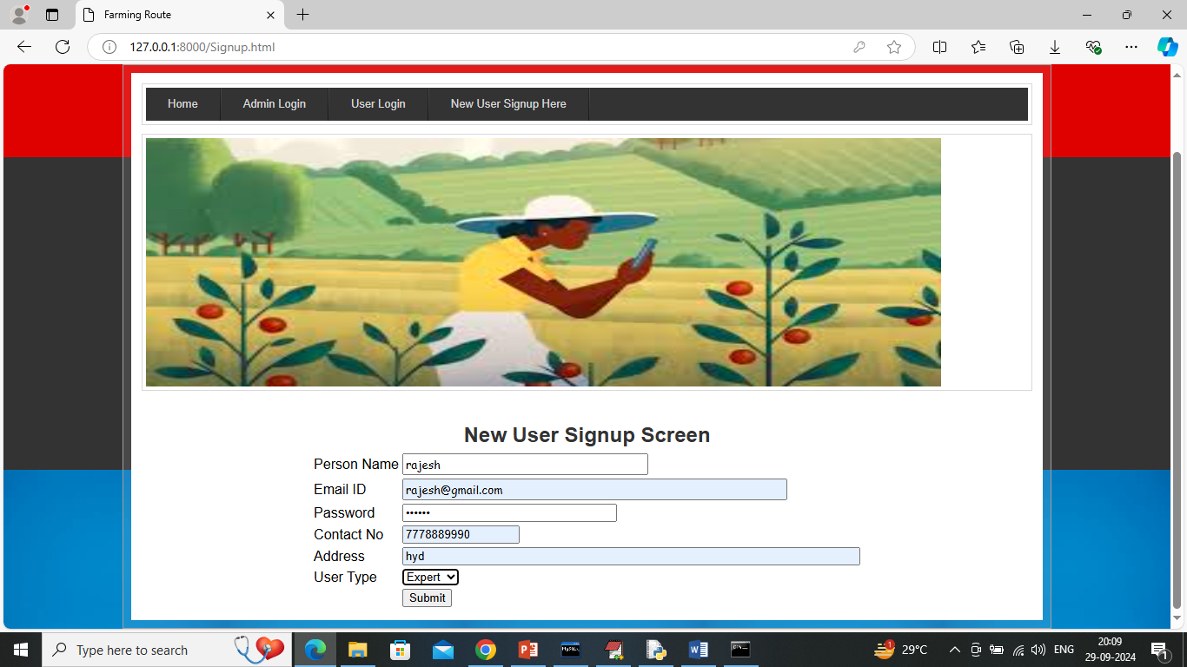

In above screen expert is entering sign up details and then press button to complete sign up task and then will get below page

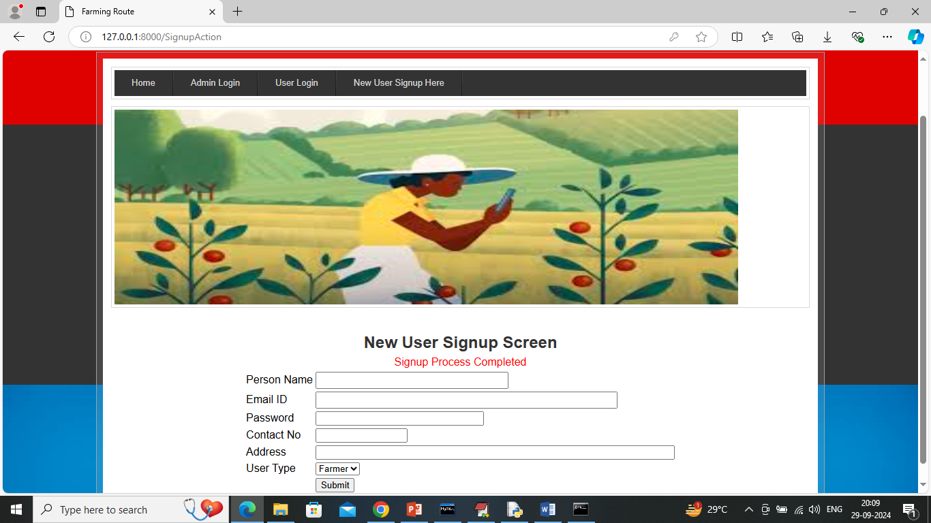

In above screen sign up completed and now click on ‘Admin Login’ to login as admin and then can activate accounts.

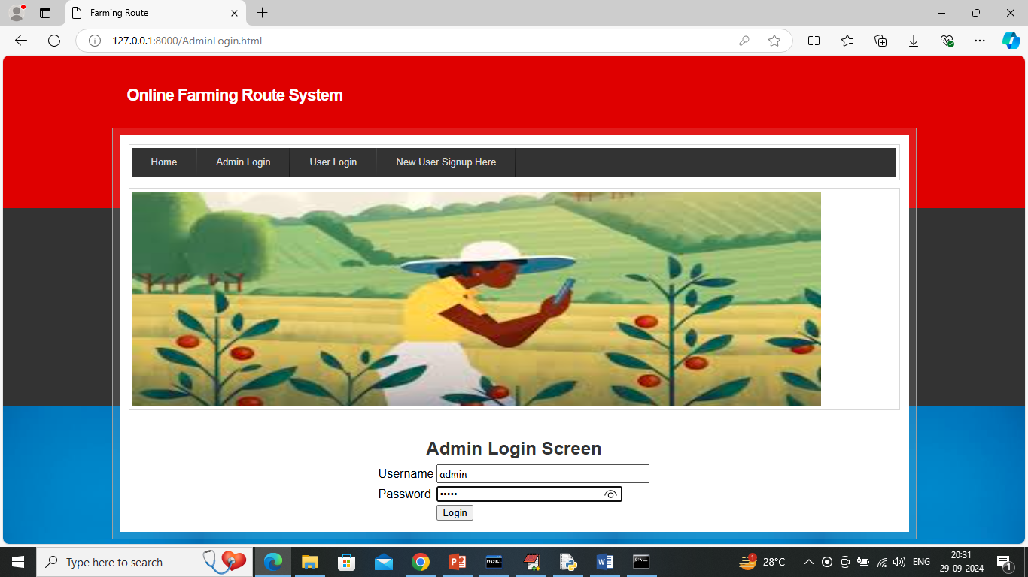

In above screen admin is login and after login will get below page

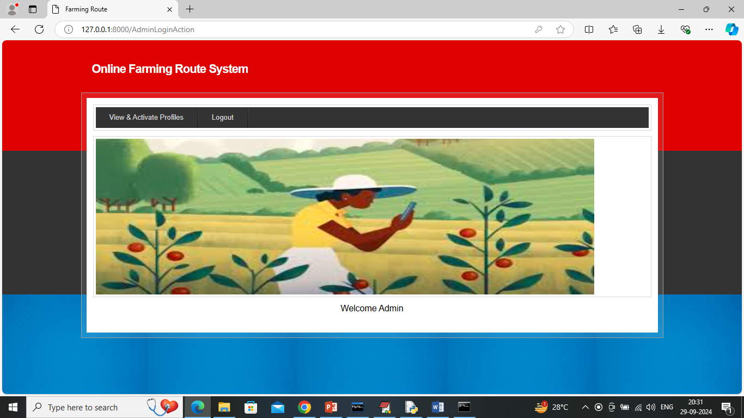

In above screen admin can click on ‘View & Activate Profiles’ link to view all accounts like below page

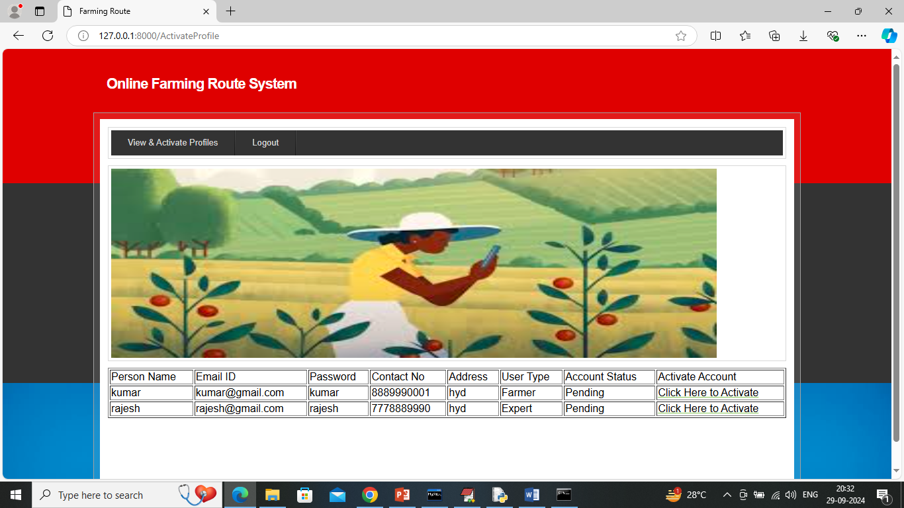

In above screen user profile is in pending state and now admin can click on ‘Click Here to Activate’ link to activate accounts and get below page

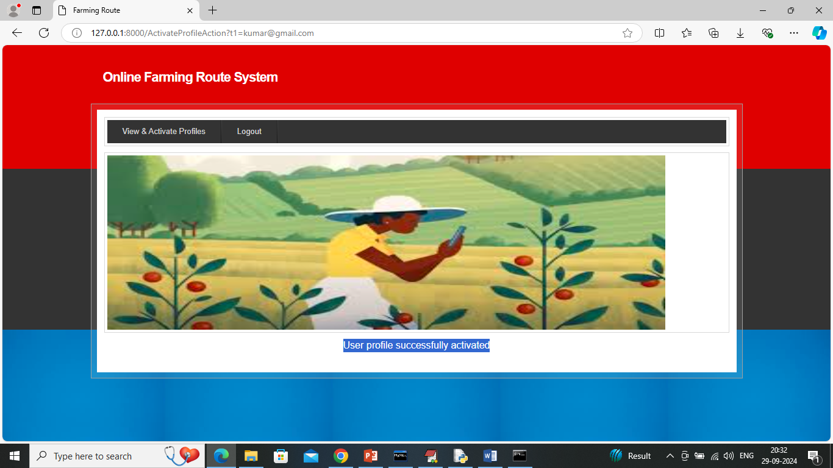

In above screen user profile is successfully activated and after activation will get below page

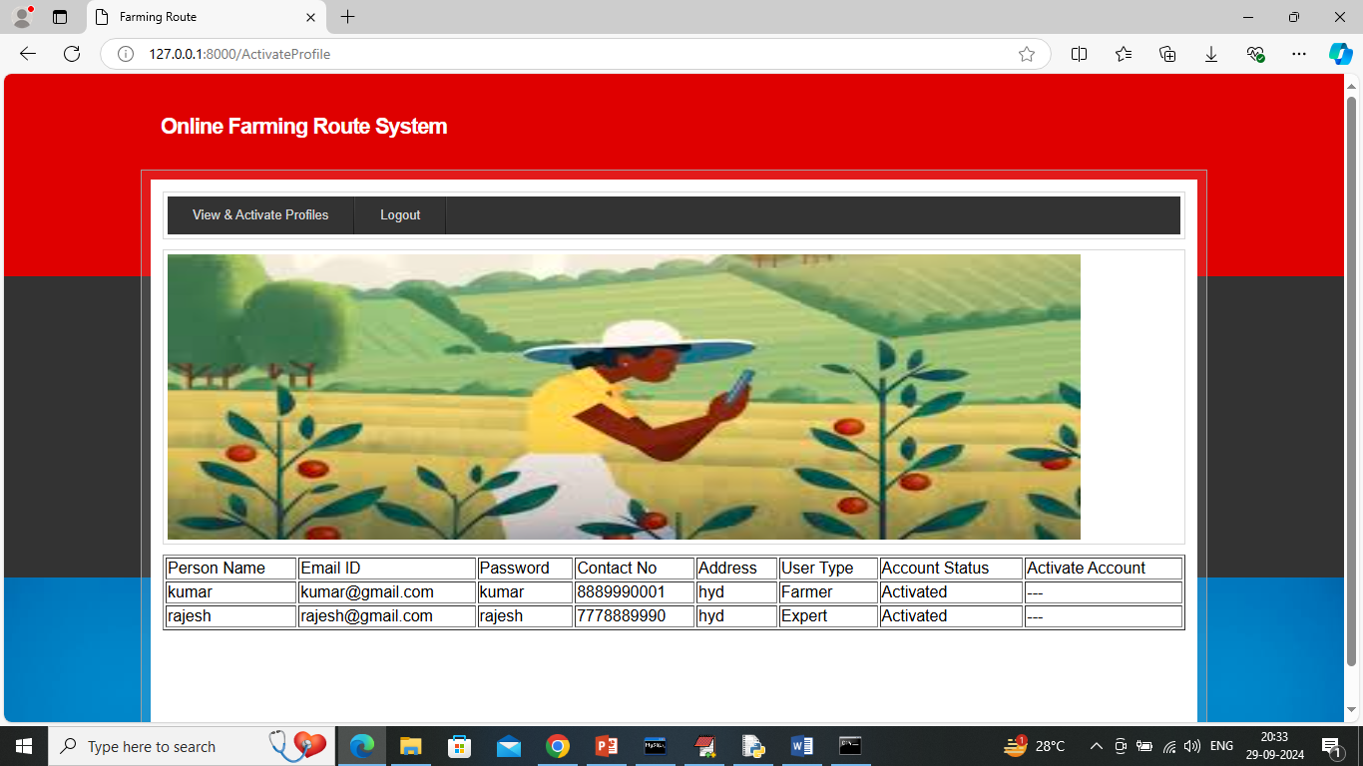

In above screen now both experts and user account is in active state and now logout and login as farmer

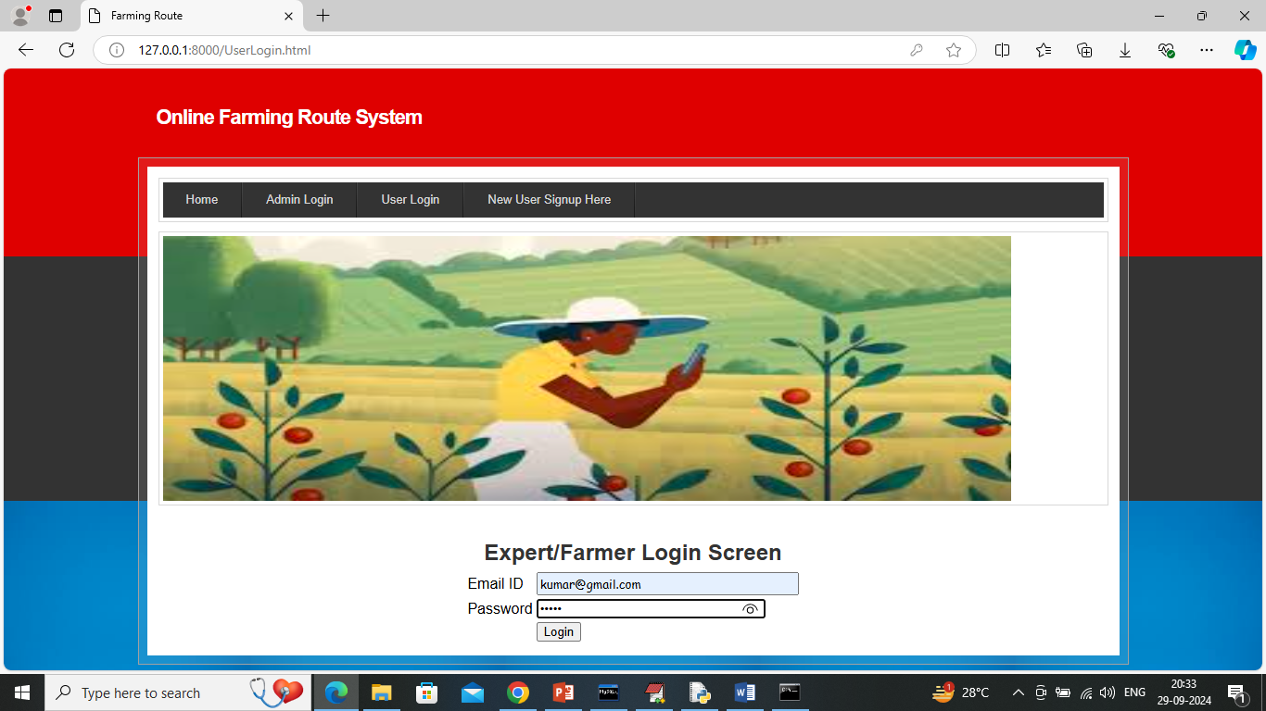

In above screen farmer is login and after login will get below page

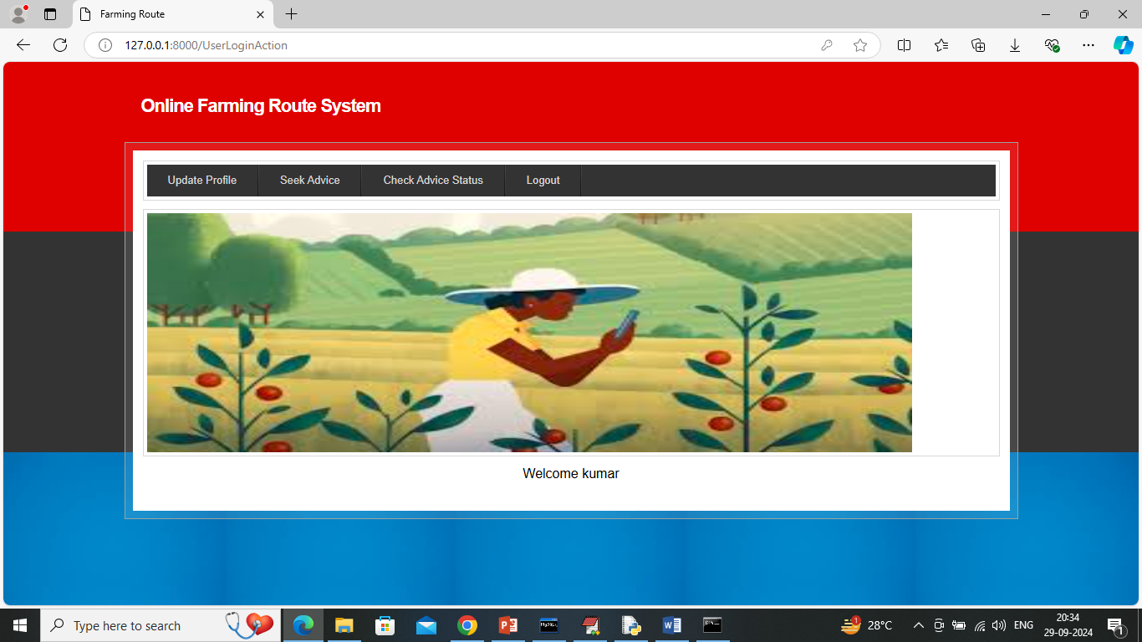

In above screen farmer can click on ‘Update Profile’ link to get below page

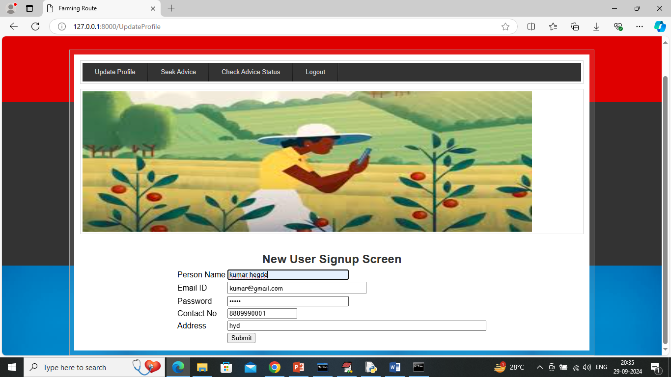

In above screen user can update desired details and then press button to get below page

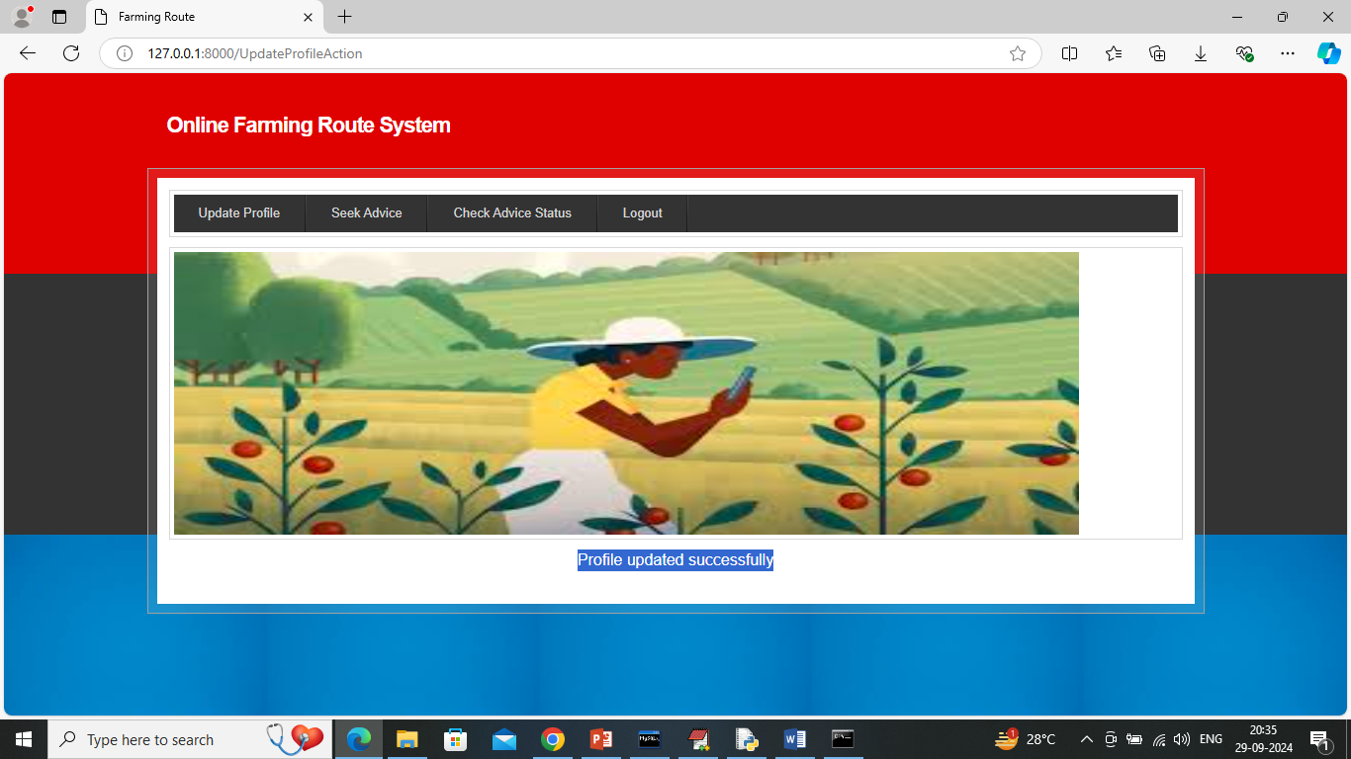

In above screen profile updated successfully and now click on ‘Seek Advice’ link to upload crop image to experts to seek advice

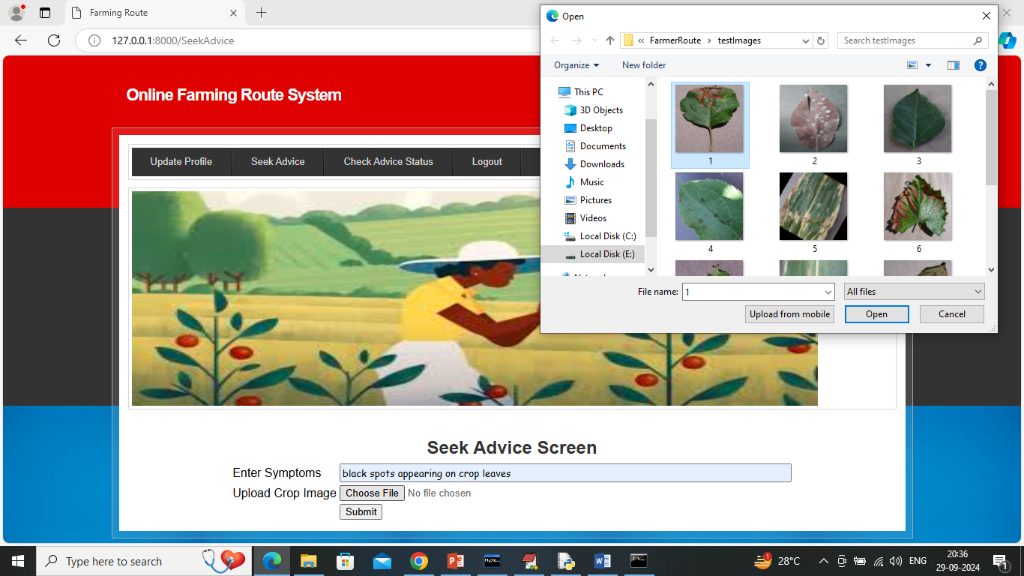

In above screen farmer entering symptoms and then uploading crop image and then click on ‘Open’ and ‘Submit’ button to get below page

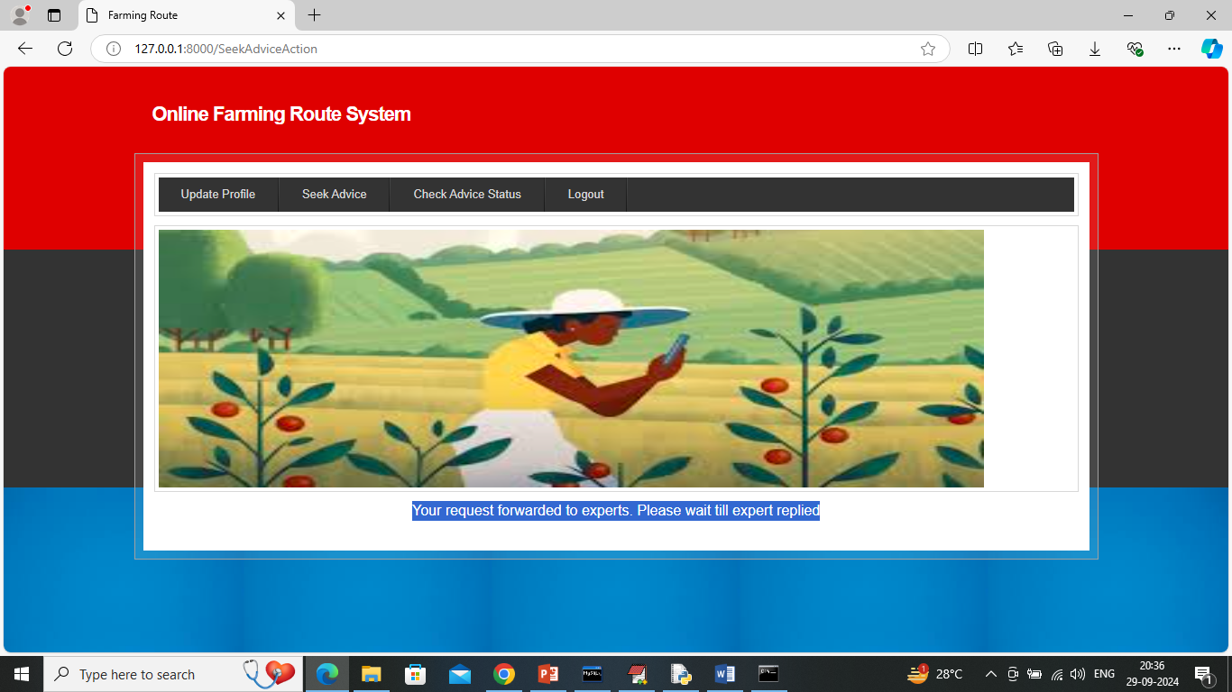

In above screen farmer request forwarded to experts and now click on ‘Check Advice Status Link' to get below page

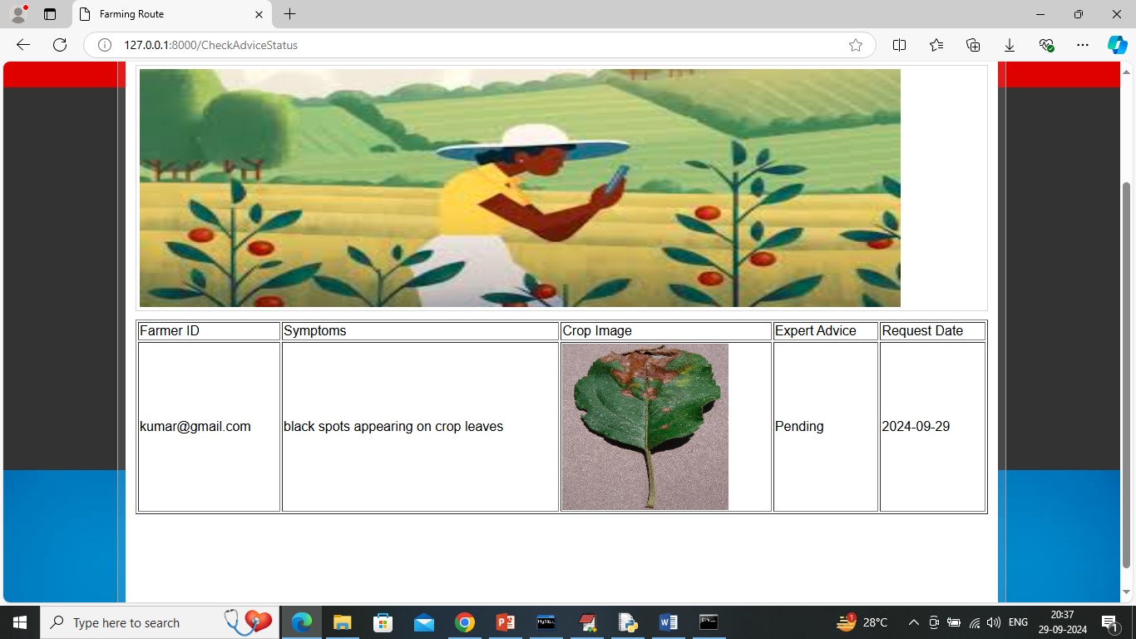

In above screen farmer can see request is sent to expert but advice is in pending state and now logout and login as experts to give suggestion

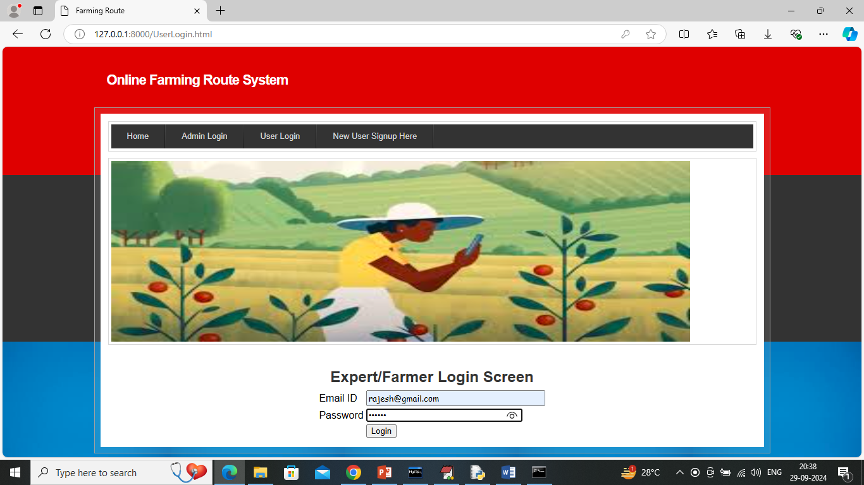

In above screen expert user is login and after login will get below page

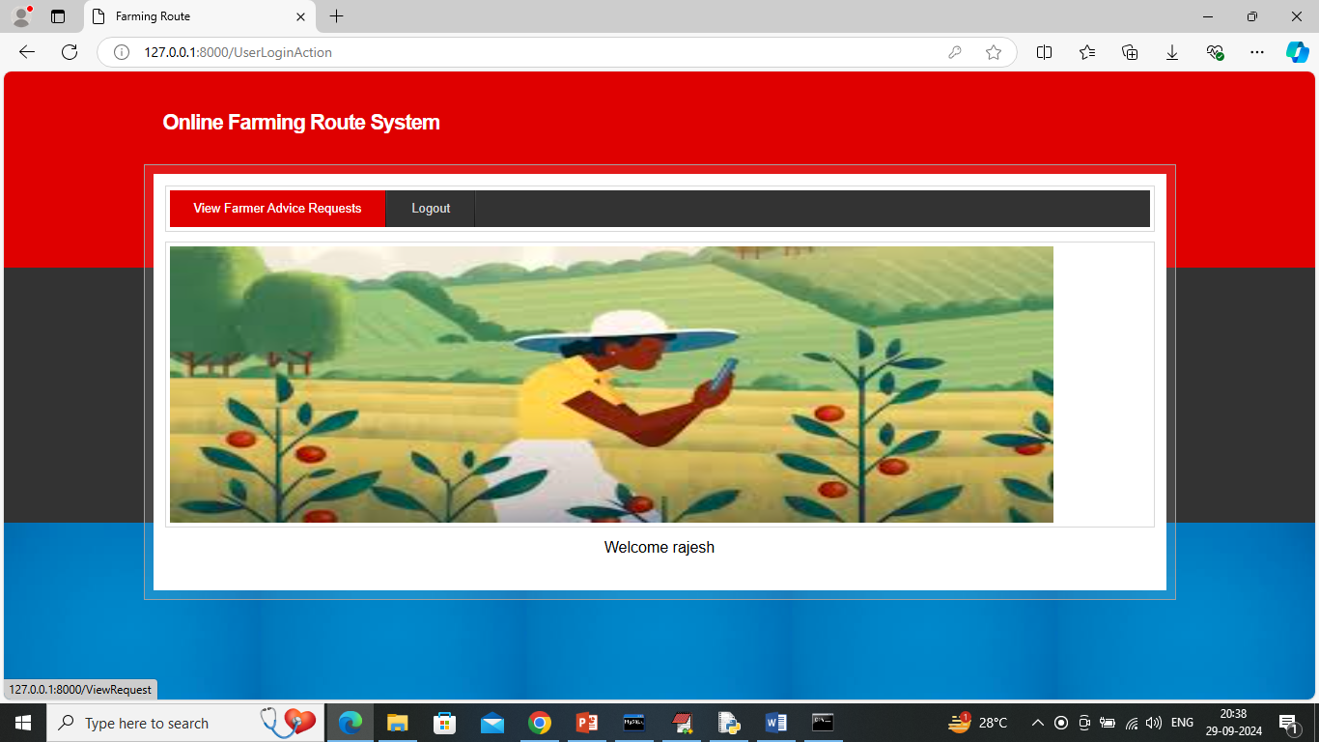

In above screen expert can click on ‘View Farmer Advice Requests’ link to view requests from farmers and get below page

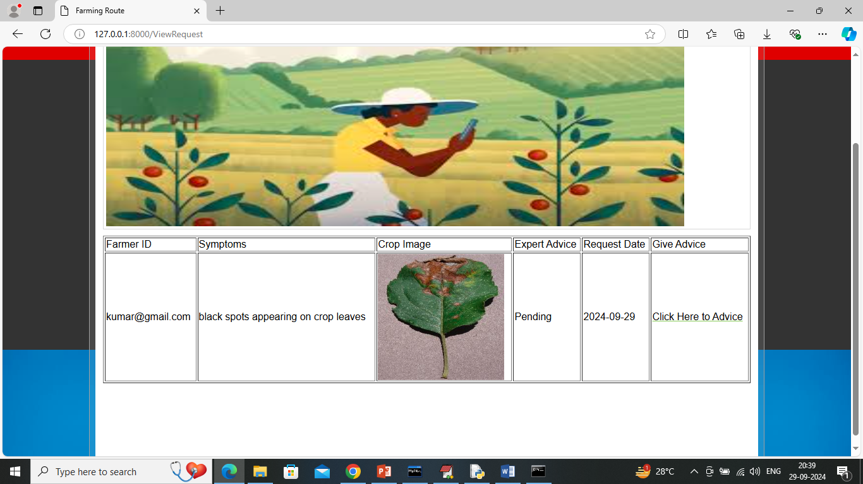

In above screen expert will view all details and then click on ‘Click Here to Advice’ link to suggest advice to farmers and get below page

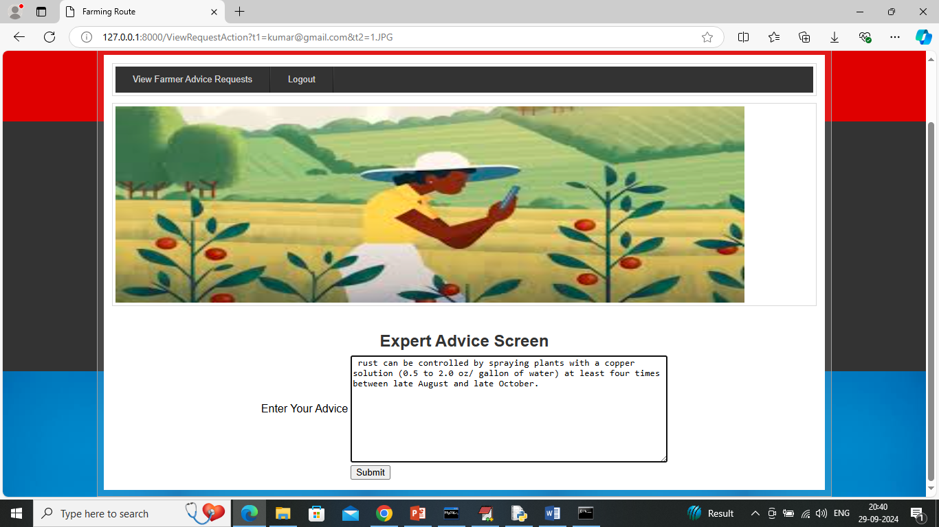

In above screen expert will write some advice and then press button to update advice and get below page

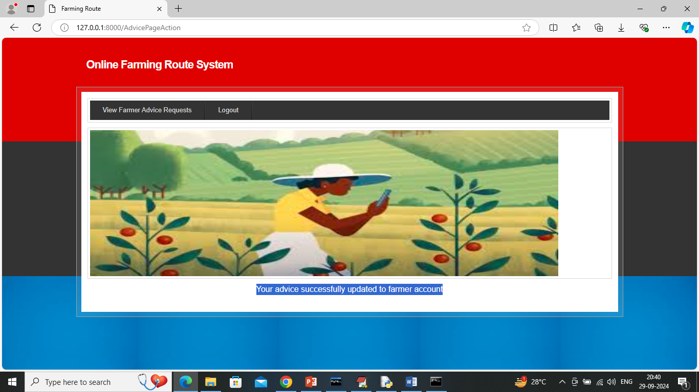

In above screen can see advice successfully sent to farmer and now farmer can login and view advice

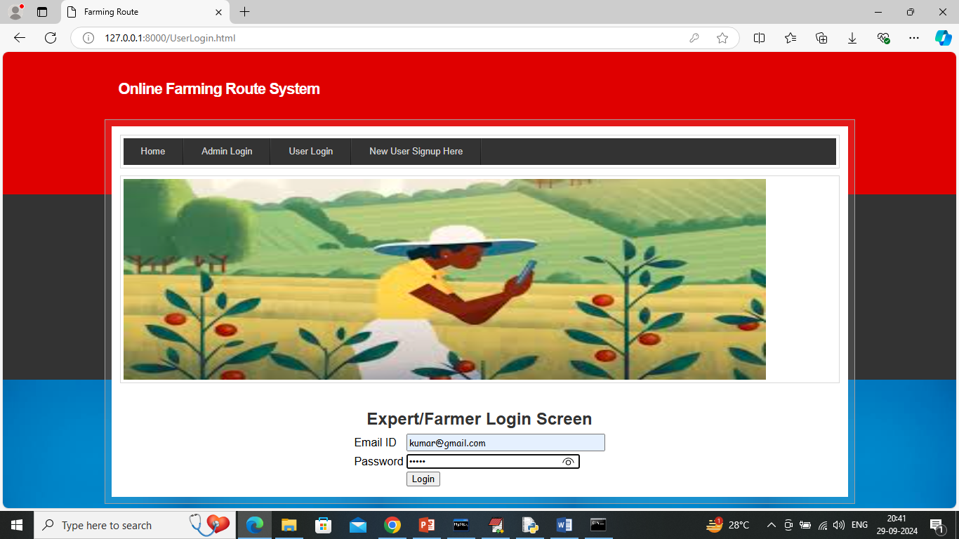

In above screen farmer is login and after login will get below page

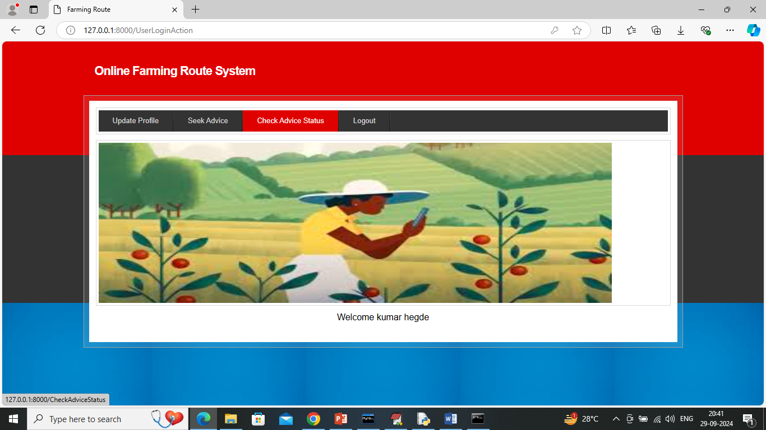

In above screen click on ‘Check Advice Status’ link to get below page

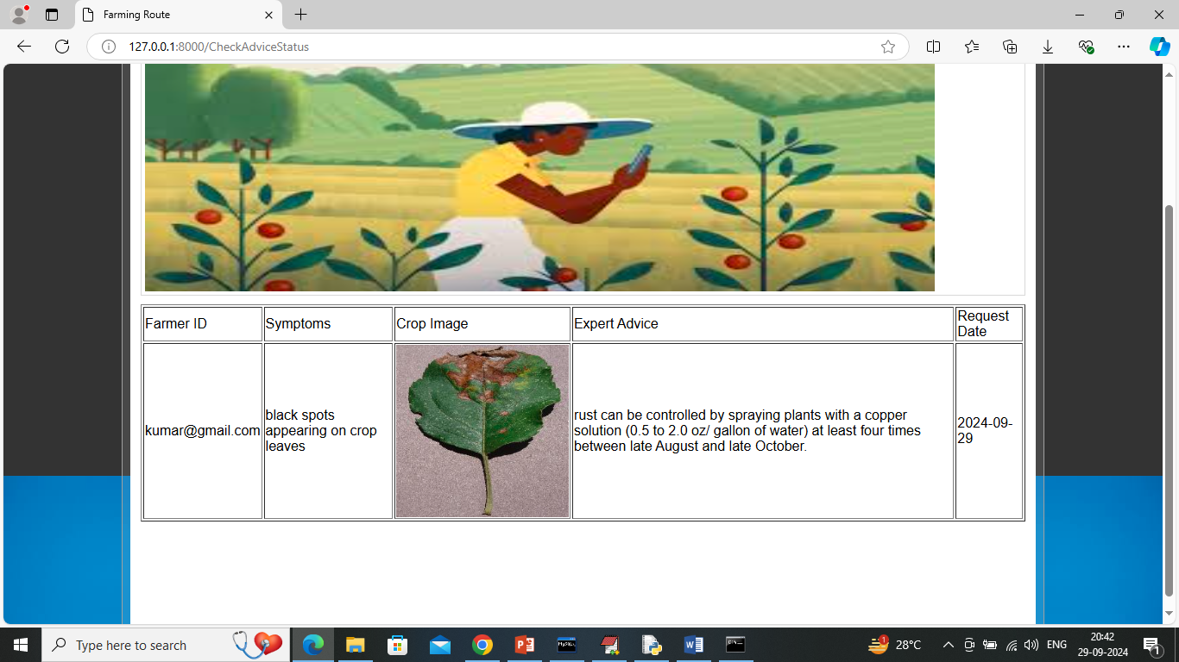

In above screen farmer can see advice given by experts.

Similarly by following above screens you can run all modules

**CHAPTER 10**

**CONCLUSION**

The **Online Farming Route System** provides a comprehensive and user-centric solution for addressing the diverse needs of farmers. Through personalized profiles and tailored advice, the system enables farmers to make informed decisions regarding crop care and disease management, helping them improve productivity and sustainability. By offering real-time recommendations and accurate disease diagnosis, the application proves to be a valuable asset in modernizing agricultural practices. As the platform continues to evolve, integrating more advanced features and expanding its scope, it holds the potential to significantly impact farming outcomes and contribute to a more sustainable and efficient agricultural ecosystem.

**REFERENCES**

1. Wolfert, S., Ge, L., Verdouw, C., & Bogaardt, M.-J. (2017). Big data in smart farming – A review. Agricultural Systems, 153, 69–80. https://doi.org/10.1016/j.agsy.2017.01.023
2. Zhang, N., Wang, M., & Wang, N. (2002). Precision agriculture—a worldwide overview. Computers and Electronics in Agriculture, 36(2–3), 113–132. https://doi.org/10.1016/S0168-1699(02)00096-0
3. Food and Agriculture Organization of the United Nations (FAO). (2019). Digital technologies in agriculture and rural areas: Briefing paper. FAO. <https://www.fao.org/3/ca4887en/ca4887en.pdf>
4. Verdouw, C., Beulens, A., Wolfert, S., & Rialland, A. (2016). Virtualization of food supply chains with the Internet of Things. Journal of Food Engineering, 176, 128-136. https://doi.org/10.1016/j.jfoodeng.2015.11.009
5. Jha, K., Doshi, A., Patel, P., & Shah, M. (2019). A comprehensive review on automation in agriculture using artificial intelligence. Artificial Intelligence in Agriculture, 2, 1–12. https://doi.org/10.1016/j.aiia.2019.05.004
6. Khanal, S., Karkee, M., & Steward, B. L. (2017). Emerging technologies for automated crop production. Agricultural Systems, 142, 66–80. https://doi.org/10.1016/j.agsy.2015.11.008
7. Liakos, K. G., Busato, P., Moshou, D., Pearson, S., & Bochtis, D. (2018). Machine learning in agriculture: A review. Sensors, 18(8), 2674. https://doi.org/10.3390/s18082674
8. Aggarwal, C. C. (2015). Data mining: The textbook. Springer. Chapter on Precision Agriculture Applications.
9. Walter, A., Finger, R., Huber, R., & Buchmann, N. (2017). Smart farming is key to developing sustainable agriculture. Proceedings of the National Academy of Sciences, 114(24), 6148-6150. https://doi.org/10.1073/pnas.1707462114
10. Ghosh, B., & Maheshwari, S. (2020). IoT-based smart agriculture: A comprehensive review. Wireless Personal Communications, 114, 817–834. https://doi.org/10.1007/s11277-020-07503-7
11. Sundmaeker, H., Verdouw, C., Wolfert, S., & Perez Freire, L. (2016). Internet of Food and Farm 2020. In Digitising the Industry - Internet of Things Connecting the Physical, Digital and Virtual Worlds (pp. 129-151). River Publishers.
12. Patil, S. K., & Kale, N. V. (2016). A model for smart agriculture using IoT. In 2016 International Conference on Global Trends in Signal Processing, Information Computing and Communication (ICGTSPICC) (pp. 543-545). IEEE. https://doi.org/10.1109/ICGTSPICC.2016.7955301
13. Kim, Y., Evans, R. G., & Iversen, W. M. (2008). Remote sensing and control of an irrigation system using a distributed wireless sensor network. IEEE Transactions on Instrumentation and Measurement, 57(7), 1379-1387. https://doi.org/10.1109/TIM.2008.917198
14. Mohanraj, I., Ashokumar, K., & Naren J. (2016). Field monitoring and automation using IoT in agriculture domain. Procedia Computer Science, 93, 931-939. https://doi.org/10.1016/j.procs.2016.07.275
15. Kamilaris, A., Kartakoullis, A., & Prenafeta-Boldú, F. X. (2017). A review on the practice of big data analysis in agriculture. Computers and Electronics in Agriculture, 143, 23-37. https://doi.org/10.1016/j.compag.2017.09.037

**APPENDIX**

**PYTHON**

**1.1 Introduction**

* One of the most popular languages is Python. Guido van Rossum released this language in 1991. Python is available on the Mac, Windows, and Raspberry Pi operating systems. The syntax of Python is simple and identical to that of English. When compared to Python, it was seen that the other language requires a few extra lines.

*It is an interpreter-based language because code may be run line by line after it has been written. This implies that rapid prototyping is possible across all platforms. Python is a big language with a free, binary-distributed interpreter standard library.

* It is inferior to maintenance that is conducted and is straightforward to learn. It is an object-oriented, interpreted programming language. It supports several different programming paradigms in addition to object-oriented programming, including functional and procedural programming.

* It supports several different programming paradigms in addition to object-oriented programming, including practical and procedural programming. Python is mighty while maintaining a relatively straightforward syntax. Classes, highly dynamic data types, modules, and exceptions are covered. Python can also be utilised by programmes that require programmable interfaces as an external language.

Here are some key features and characteristics of Python:

* Readability: Python emphasizes code readability with its clean and intuitive syntax. It uses indentation and whitespace to structure code blocks, making it easy to understand and maintain.
* Easy to Learn: Python's simplicity and readability make it an excellent choice for beginners. Its straightforward syntax and extensive documentation make it accessible for newcomers to programming.
* Interpreted Language: Python is an interpreted language, meaning that it doesn't need to be compiled before running. The Python interpreter reads and executes the code directly, making the development process faster and more interactive.
* Cross-platform Compatibility: Python is available for major operating systems like Windows, macOS, and Linux. This cross-platform compatibility allows developers to write code once and run it on different platforms without modifications.
* Large Standard Library: Python comes with a vast standard library that provides ready-to-use modules and functions for various tasks. It covers areas such as file I/O, networking, regular expressions, databases, and more, saving developers time and effort.
* Extensible and Modular: Python supports modular programming, enabling developers to organize code into reusable modules and packages. Additionally, Python allows integrating modules written in other languages, such as C or C++, providing flexibility and performance optimizations.
* Wide Range of Libraries and Frameworks: Python has a vibrant ecosystem with numerous third-party libraries and frameworks. These libraries, such as NumPy, pandas, TensorFlow, and Django, extend Python's capabilities for specific domains, making it a powerful tool for diverse applications.
* Object-Oriented: Python supports object-oriented programming (OOP) principles, allowing developers to create and work with classes and objects. OOP provides a structured approach to code organization, promoting code reuse and modularity.
* Dynamic Typing: Python is dynamically typed, meaning variable types are determined at runtime. Developers do not need to declare variable types explicitly, which enhances flexibility and simplifies code writing.

**1.2 Installation**

To install Python on your computer, follow these basic steps:

* Step 1: Visit the Python website Go to the official Python website at <https://www.python.org/>.
* Step 2: Select the operating system Choose the appropriate installer for your operating system. Python supports Windows, macOS, and various Linux distributions. Make sure to select the correct version that matches your operating system.
* Step 3: Check which version of Python is installed; if the 3.7.0 version is not there, uninstall it through the control panel and
* Step 4: Install Python 3.7.0 using Cmd.
* Step 5: Install the all libraries that required to run the project
* Step 6: Run

**1.3 Python Features:**

1. **Easy:** Because Python is a more accessible and straightforward language, Python programming is easier to learn.
2. **Interpreted language:** Python is an interpreted language, therefore it can be used to examine the code line by line and provide results.
3. **Open Source:** Python is a free online programming language since it is open-source.
4. **Portable:** Python is portable because the same code may be used on several computer standard
5. **libraries:** Python offers a sizable library that we may utilize to create applications quickly.
6. **GUI:** It stands for GUI (Graphical User Interface)
7. **Dynamical typed:** Python is a dynamically typed language, therefore the type of the value will be determined at runtime.

**1.4 Python GUI (Tkinter)**

* Python provides a wide range of options for GUI development (Graphical User Interfaces).
* Tkinter, the most widely used GUI technique, is used for all of them.
* The Tk GUI toolkit offered by Python is used with the conventional Python interface.
* Tkinter is the easiest and quickest way to write Python GUI programs.
* Using Tkinter, creating a GUI is simple.
* A part of Python's built-in library is Tkinter. The GUI programs were created.
* Python and Tkinter together give a straightforward and quick way. The Tk GUI toolkit's object-oriented user interface is called Tkinter.

Making a GUI application is easy using Tkinter. Following are the steps:

1) Install the Tkinter module in place.

2) The GUI applicatioMakeske the primary window

3) Include one or more of the widgets mentioned above in the GUI application.

4) Set up the main event loop such that it reacts to each user-initiated event.

Although Tkinter is the only GUI framework included in the Python standard library, Python includes a GUI framework. The default library for Python is called Tkinter. Tk is a scripting language often used in designing, testing, and developing GUIs. Tk is a free, open-source widget toolkit that may be used to build GUI applications in a wide range of computer languages.

**1.5 Python IDLE**

* Python IDLE offers a full-fledged file editor, which gives you the ability to write and execute Python programs from within this program. The built-in file editor also includes several features, like code completion and automatic indentation, that will speed up your coding workflow.
* Guido Van Rossum named Python after the British comedy group Monty Python while the name IDLE was chosen to pay tribute to Eric Idle, who was one of the Monty Python's founding members. IDLE comes bundled with the default implementation of the Python language since the 01.5. 2b1 release
* IDLE is used to execute statements similar to Python Shell. IDLE is used to create, modify, and execute Python code. IDLE provides a fully-featured text editor to write Python scripts and provides features like syntax highlighting, auto-completion, and smart indent.
* IDLE has two modes: interactive and script. We wrote our first program, “Hello, World!” in interactive mode. Interactive mode immediately returns the results of commands you enter into the shell. In script mode, you will write a script and then run it.
* The IDE Python IDLE is a good place to start as it helps you become familiar with the way Python works and understand its syntax. This IDE is good to start programming in Python due to its great debugger, but once you are fluent and start developing projects it is necessary to jump to another, more complete IDE.
* Python IDLE (Integrated Development and Learning Environment) is an interactive development environment included with the Python programming language. It provides a convenient way to write, execute, and debug Python code.

When you install Python, IDLE is typically installed along with it. To open IDLE, you can follow these steps:

* Open the command prompt (Windows) or terminal (macOS/Linux).
* Type "idle" and press Enter. Alternatively, you can specify the version with "idle3" or "idle2" for Python 3 or Python 2, respectively.
* Once IDLE is launched, you will see the Python shell, which is an interactive environment where you can type and execute Python code directly.

Here are some features and functionalities provided by Python IDLE:

* Editor: IDLE includes a text editor where you can write your Python code. It offers syntax highlighting, automatic indentation, and code completion to enhance your coding experience.
* Interactive Shell: The Python shell in IDLE allows you to execute Python code interactively. You can type commands, statements, or function calls directly in the shell, and Python will execute them immediately.
* Debugging: IDLE provides basic debugging capabilities to help you find and fix errors in your code. You can set breakpoints, step through code, inspect variables, and track the program's execution.
* Python Help: IDLE provides access to the Python documentation and built-in help. You can access the help menu to find information about Python modules, functions, classes, and more.
* Script Execution: In addition to the interactive shell, IDLE allows you to run Python scripts stored in files. You can write your code in the editor and execute it as a script to see the output or interact with the program.
* Customization: IDLE can be customized to suit your preferences. You can modify settings related to syntax highlighting, indentation, fonts, and more.
* Python IDLE serves as a beginner-friendly development environment and learning tool. It is suitable for writing small scripts, testing code snippets, experimenting with Python features, and learning the language's basics. However, for more advanced development projects, you may consider using other code editors or integrated development environments (IDEs) that provide additional features and better project management capabilities.

**1.6 Libraries**

In Python, libraries (also referred to as modules or packages) are collections of pre-written code that provide additional functionality and tools to extend the capabilities of the Python language. Libraries contain reusable code that developers can leverage to perform specific tasks without having to write everything from scratch.

Python libraries are designed to solve common problems, such as handling data, performing mathematical operations, interacting with databases, working with files, implementing networking protocols, creating graphical user interfaces (GUIs), and much more. They provide ready-to-use functions, classes, and methods that simplify complex operations and save development time.

**Libraries in Python offer various advantages:**

* Code Reusability:
* Efficiency:
* Collaboration
* Domain-Specific Functionality
* To use a Python library, you need to install it first.

There are some libraries following:

* **Pandas:**

Pandas are a Python computer language library for data analysis and manipulation. It offers a specific operation and data format for handling time series and numerical tables. It differs significantly from the release3-clause of the BSD license. It is a well-liked open-source of opinion that is utilized in machine learning and data analysis.

Pandas are a Python package providing fast, flexible, and expressive data structures designed to make working with “relational” or “labeled” data both easy and intuitive. It aims to be the fundamental high-level building block for doing practical, real-world data analysis in Python. Pandas are a Python library used for working with data sets.

* It has functions for analysing, cleaning, exploring, and manipulating data.
* The name "Pandas" has a reference to both "Panel Data", and "Python Data Analysis" and was created by Wes McKinney in 2008.
* Pandas allow us to analyse big data and make conclusions based on statistical theories.
* Pandas can clean messy data sets, and make them readable and relevant.

Relevant data is very important in data science. Pandas are a Python library for data analysis. Started by Wes McKinney in 2008 out of a need for a powerful and flexible quantitative analysis tool, pandas have grown into one of the most popular Python libraries. It has an extremely active community of contributors. The name is derived from the term "panel data", an econometrics term for data sets that include observations over multiple time periods for the same individuals. Its name is a play on the phrase "Python data analysis" itself.

* **NumPy:**

The NumPy Python library for multi-dimensional, big-scale matrices adds a huge number of high-level mathematical functions. It is possible to modify NumPy by utilizing a Python library. Along with line, algebra, and the Fourier transform operations, it also contains several matrices-related functions.

NumPy can be used to perform a wide variety of mathematical operations on arrays. It adds powerful data structures to Python that guarantee efficient calculations with arrays and matrices and it supplies an enormous library of high-level mathematical functions that operate on these arrays and matrices.

* NumPy is a Python library used for working with arrays.
* It also has functions for working in domain of linear algebra, Fourier transform, and matrices.
* NumPy was created in 2005 by Travis Oliphant. It is an open source project and you can use it freely.
* NumPy stands for Numerical Python.
* In Python we have lists that serve the purpose of arrays, but they are slow to process.
* NumPy aims to provide an array object that is up to 50x faster than traditional Python lists.
* The array object in NumPy is called ndarray, it provides a lot of supporting functions that make working with ndarray very easy.
* Arrays are very frequently used in data science, where speed and resources are very important.
* **Matplotlib:**

It is a multi-platform, array-based data visualization framework built to interact with the whole SciPy stack. MATLAB is proposed as an open-source alternative. Matplotlib is a Python extension and a cross-platform toolkit for graphical plotting and visualization.

Matplotlib is a popular Python library for creating static, animated, and interactive visualizations. It provides a flexible and comprehensive set of tools for generating plots, charts, histograms, scatter plots, and more. Matplotlib is widely used in various fields, including data analysis, scientific research, and data visualization.

Here are some key features and functionalities of the Matplotlib library:

* Plotting Functions
* Customization Options
* Multiple Interfaces
* Integration with NumPy and pandas
* Subplots and Figures:
* Saving and Exporting
* **Scikit-learn:**

The most stable and practical machine learning library for Python is scikit-learn. Regression, dimensionality reduction, classification, and clustering are just a few of the helpful tools it provides through the Python interface for statistical modeling and machine learning. It is an essential part of the Python machine learning toolbox used by JP Morgan. It is frequently used in various machine learning applications, including classification and predictive analysis.

Scikit-learn (also referred to as sklearn) is a widely used open-source machine learning library for Python. It provides a comprehensive set of tools and algorithms for various machine learning tasks, including classification, regression, clustering, dimensionality reduction, model selection, and pre-processing.

Here are some key features and functionalities of the Scikit-learn library:

* Easy-to-Use Interface:
* Broad Range of Algorithms:
* Data Pre-processing and Feature Engineering:
* Model Evaluation and Validation:
* Integration with NumPy and pandas:
* Robust Documentation and Community Support:
* **Keras:**

* Google's Keras is a cutting-edge deep learning API for creating neural networks. It is created in Python and is designed to simplify the development of neural networks. Additionally, it enables the use of various neural networks for computation. Deep learning models are developed and tested using the free and open-source Python software known as Keras.

Keras is a high-level deep learning library for Python. It is designed to provide a user-friendly and intuitive interface for building and training deep learning models. Keras acts as a front-end API, allowing developers to define and configure neural networks while leveraging the computational backend engines, such as Tensor Flow or Theano.

Here are some key features and functionalities of the Keras library:

* User-Friendly API
* Multi-backend Support
* Wide Range of Neural Network Architectures
* Pre-trained Models and Transfer Learning:
* Easy Model Training and Evaluation:
* GPU Support:
* **h5py:**

* The h5py Python module offers an interface for the binary HDF5 data format. Thanks to p5py, the top can quickly halt the vast amount of numerical data and alter it using the NumPy library. It employs common syntax for Python, NumPy, and dictionary arrays.

h5py is a Python library that provides a simple and efficient interface for working with datasets and files in the Hierarchical Data Format 5 (HDF5) format. HDF5 is a versatile data format commonly used for storing and managing large volumes of numerical data.

Here are some key features and functionalities of the h5py library:

* + HDF5 File Access
  + Dataset Handling:
  + Group Organization:
  + Attributes:
  + Compatibility with NumPy
  + Performance
* **Tensor flow**

TensorFlow is a Python library for fast numerical computing created and released by Google. It is a foundation library that can be used to create Deep Learning models directly or by using wrapper libraries that simplify the process built on top of TensorFlow. TensorFlow is an end-to-end open source platform for machine learning. TensorFlow is a rich system for managing all aspects of a machine learning system; however, this class focuses on using a particular TensorFlow API to develop and train machine learning models.

TensorFlow is a popular open-source library for machine learning and deep learning. It provides a comprehensive set of tools, APIs, and computational resources for building and training various types of machine learning models, especially neural networks.

Here are some key features and functionalities of TensorFlow:

* Neural Network Framework:
* Computational Graphs
* Automatic Differentiation
* GPU and TPU Support
* Distributed Computing
* Deployment Capabilities
* **Tkinter**

Tkinter is an acronym for "Tk interface". Tk was developed as a GUI extension for the Tcl scripting language by John Ousterhout. The first release was in 1991. Tkinter is the de facto way in Python to create Graphical User interfaces (GUIs) and is included in all standard Python Distributions. In fact, it's the only framework built into the Python standard library.

Tkinter is a standard Python library used for creating graphical user interfaces (GUIs). It provides a set of modules and classes that allow you to develop interactive and visually appealing desktop applications.

Here are some key features and functionalities of Tkinter:

* Cross-Platform Compatibility
* Simple and Easy-to-Use
* Widgets and Layout Management
* Event-Driven Programming
* Customization and Styling
* Integration with Other Libraries
* **NLTK**

NLTK is a toolkit build for working with NLP in Python. It provides us various text processing libraries with a lot of test datasets. A variety of tasks can be performed using NLTK such as tokenizing, parse tree visualization, etc NLTK (Natural Language Toolkit) is the go-to API for NLP (Natural Language Processing) with Python. It is a really powerful tool to pre-process text data for further analysis like with ML models for instance. It helps convert text into numbers, which the model can then easily work with.

NLTK (Natural Language Toolkit) is a Python library widely used for working with human language data and implementing natural language processing (NLP) tasks. It provides a set of tools, corpora, and resources for tasks such as tokenization, stemming, tagging, parsing, sentiment analysis, and more.

Here are some key features and functionalities of NLTK:

* Text Processing
* Part-of-Speech Tagging
* Named Entity Recognition
* Chunking and Parsing
* Sentiment Analysis:
* WordNet Integration:
* **Scipy**

SciPy is a collection of mathematical algorithms and convenience functions built on the NumPy extension of Python. It adds significant power to the interactive Python session by providing the user with high-level commands and classes for manipulating and visualizing data.

SciPy is a powerful scientific computing library for Python that provides a wide range of mathematical algorithms and functions. It builds upon NumPy, another fundamental library for numerical computing, and extends its capabilities by adding additional tools for scientific and technical computing tasks.

Here are some key features and functionalities of SciPy:

* Numerical Integration:
* Optimization and Root Finding
* Linear Algebra
* Signal and Image Processing
* Statistics

**MYSQL**

MySQL, the most popular Open Source SQL database management system, is developed, distributed, and supported by Oracle Corporation. The MySQL Database Software is a client/server system that consists of a multithreaded SQL server that supports different back ends, several different client programs and libraries, administrative tools, and a wide range of application programming interfaces. MySQL is an open-source relational database management system (RDBMS) that is widely used for building and managing databases. It is known for its speed, reliability, and ease of use. MySQL databases are used in a variety of applications, ranging from small personal projects to large-scale enterprise systems. MySQL follows the relational database model, which organizes data into structured tables with rows and columns.

MySQL uses SQL as its query language. SQL enables you to interact with the database by performing operations such as creating, reading, updating, and deleting data, as well as defining the structure of the database. MySQL provides multiple storage engines that handle how data is stored, accessed, and managed. MySQL databases can be scaled both vertically and horizontally. MySQL offers features for user authentication, authorization, and encryption to ensure the security of the data stored in the database. MySQL provides tools and utilities for performing backups and recovering data in case of failures. MySQL has a large and active open-source community. In addition to the open-source version, there are also commercial versions of MySQL offered by Oracle that provide additional features and support. MySQL is a widely used relational database management system (RDBMS). MySQL is open source ad free. MySQL is ideal for both large and small applications.